Multiple Regression Model

Model: 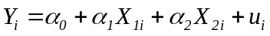
Estimation of the Coefficients
From the model specified above, we have 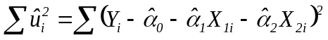
Objective is to minimize with respect to 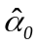, 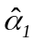and 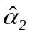
Hence, 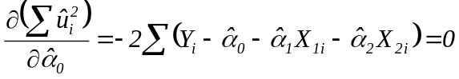 or 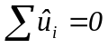 (1)
Similarly, 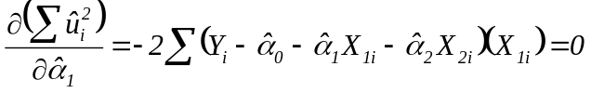 or 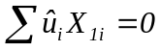 (2)
Further, 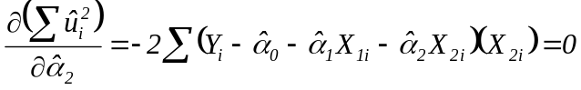 or 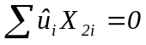 (3)
Solving these equations, we get
- 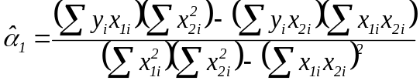; (b)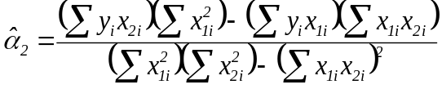 and (c) 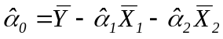
Further, from (2) we have
Hence, 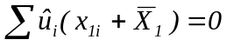 or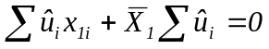
Or 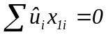 [as]
Similarly, from (3) we have
Hence, 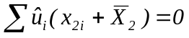or 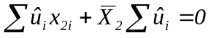
Or, 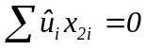 [as]
Further,
Similarly,
On the other hand,
Implications of Multicollinearity:
- If there is perfect multicollinearity between X₁ and X₂, i.e., 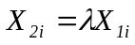,
Here, and 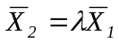 implying that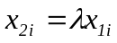

Or, 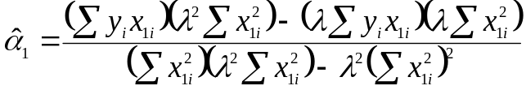

Or, 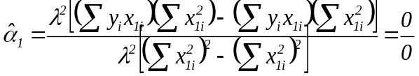

Similarly, 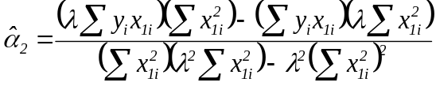

- 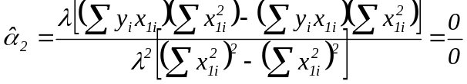

Further,
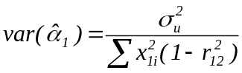;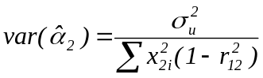; 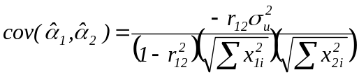
If there is perfect multicollinearity between X₁ and X₂, i.e., 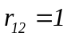

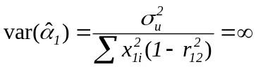 and 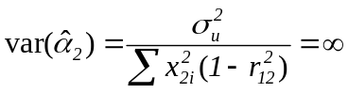

This means that the standard errors of the OLS estimators of the slope coefficients will be infinitely large. This will subsequently affect the respective test statistics.

- If there is no multicollinearity between X₁ and X₂, i.e., 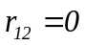;
Consider the following models:
(1); (2)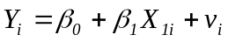; (3) 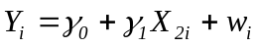
(4)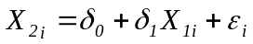; (5) 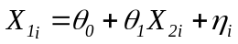
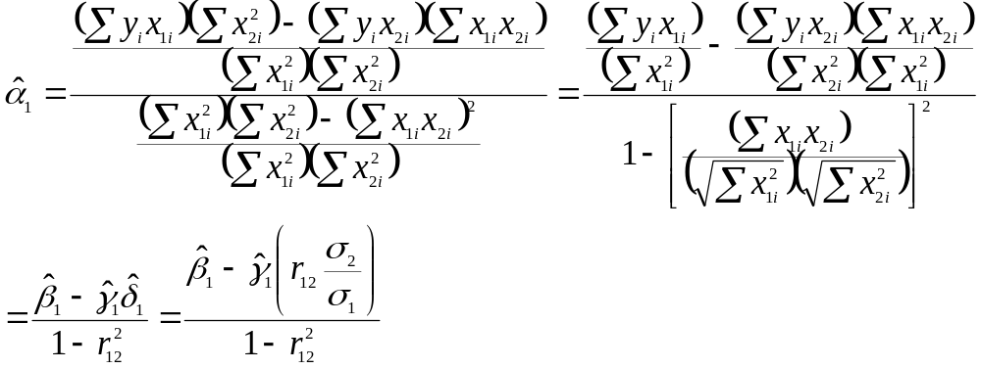
σ₁ = standard deviation of X₁; σ₂ = standard deviation of X₂
This means that when , 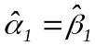
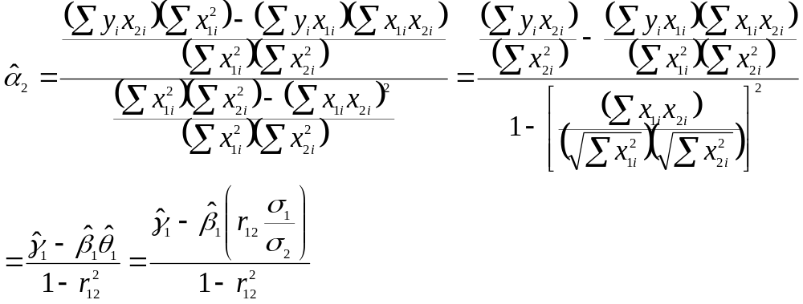
This means that when , 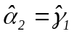

Further, if there is no multicollinearity between X₁ and X₂, i.e., 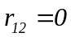

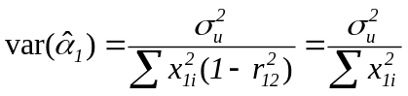 and 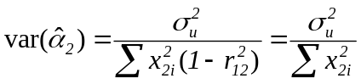

- Decomposition of Goodness-of-Fit
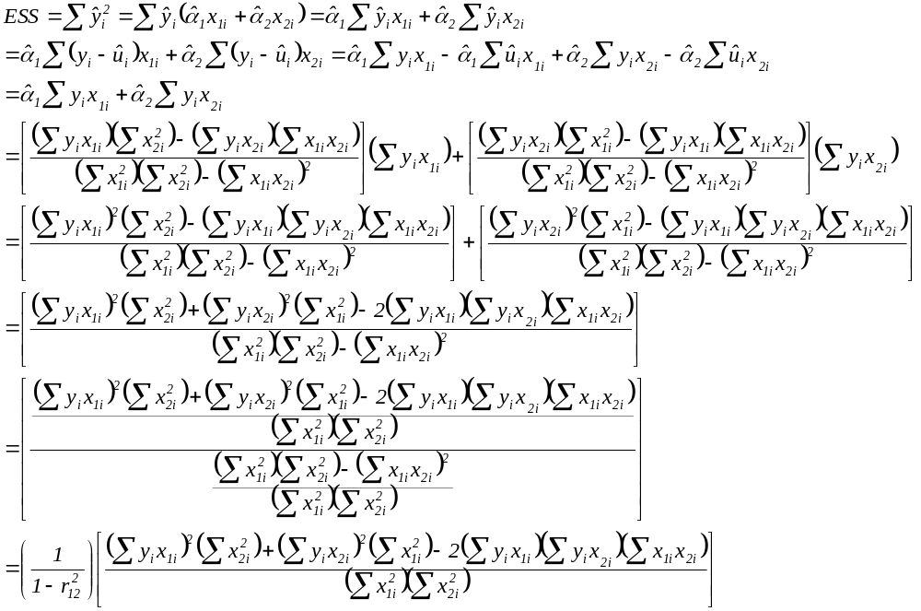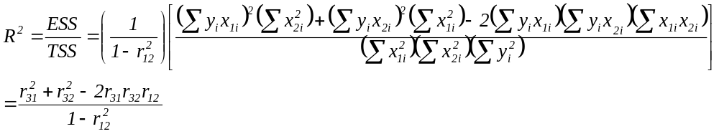
Testing of Hypothesis

Model:

- For the Overall Model

Null Hypothesis 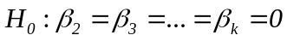
Alternative Hypothesis: At least one of the slope coefficient is different from zero

Test Statistics; 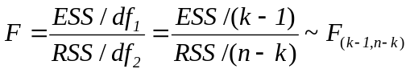

- For the Individual Coefficients

Two-tailed Test: Null Hypothesis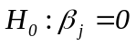; Alternative Hypothesis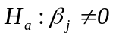
One-tailed Test: Null Hypothesis ; Alternative Hypothesis 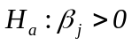 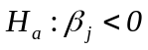

Test Statistic: 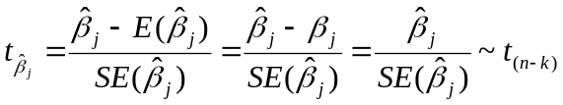 where 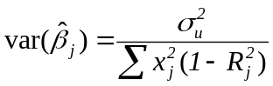 (This estimator of variance is only for the slope coefficients - except the intercept)

Goodness-of-Fit

Derivation of Adjusted 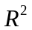

We have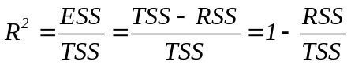

Or,

When 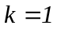, 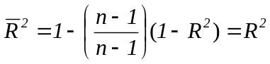
Similarly, when 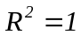, 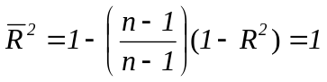
On the other hand, when 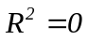, 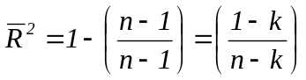
In this case, 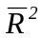will be negative for 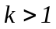

Comparing Two Coefficients of a Multiple Regression Model:
Model:
Test Hypothesis: 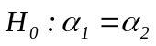 or 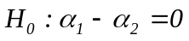
- Through t Test:
Test Statistic: 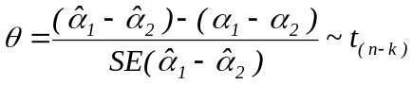
By the Null Hypothesis 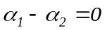 and
- 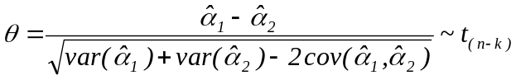
;;
- Through Restricted F Test:
Unrestricted Model:
Restriction: 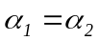
- Restricted Model:
Test Statistic: 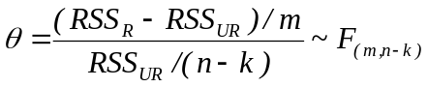
Here, m stands for the number of restrictions
Example: Examine if the production function 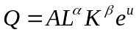follows constant returns to scale
Production Function: ; Unrestricted Model:
Test Hypothesis: 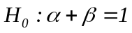 or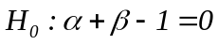
Through t Test
Test Statistic: 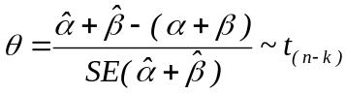 or 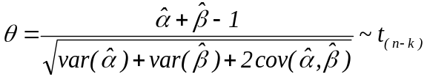
Through Restricted F Test:
Restriction: 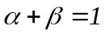 or 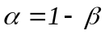
Restricted Model:
- or 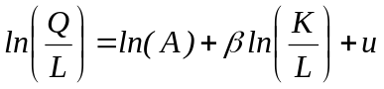
Test Statistic:

Testing for Validity of Restrictions

- Testing for Inclusion/Exclusion of Variables

Case I:
Unrestricted Model:
Restriction: 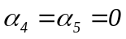
Null Hypothesis: 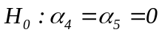; Alternative Hypothesis: At least one of these additional slope coefficients is different from zero

Restricted Model: 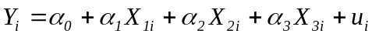

Restricted F Test: (Here, m stands for the number of restrictions and k for the number of coefficients)

Rejection of the Null Hypothesis indicates that the unrestricted model should be selected.

Case II:
Unrestricted Model:
Restriction: 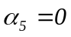
Null Hypothesis: 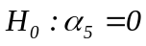; Alternative Hypothesis: The additional slope coefficient is different from zero

Restricted Model:

Restricted F Test: (Here, m stands for the number of restrictions and k for the number of coefficients)

Through t Test: Test Statistic: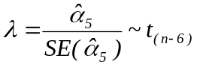

Rejection of the Null Hypothesis in either case indicates that the unrestricted model should be selected.

- Testing for Equality of Coefficients
Unrestricted Model:
Restriction: 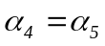 ; Null Hypothesis: 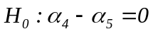; Alternative Hypothesis: These slope coefficients are significantly different
Restricted Model:

Restricted F Test: (Here, m stands for the number of restrictions and k for the number of coefficients)

Through t Test: Test Statistic: or
Rejection of the Null Hypothesis in either case indicates that the coefficients are statistically significantly different

- Testing for Validity of Restriction
Production Function: ; Unrestricted Model: ; Restriction: 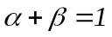 or 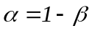
Null Hypothesis: or; Alternative Hypothesis: The production function does not follow CSR

Through t Test: Test Statistic: or
Through Restricted F Test:
Restricted Model: or

Test Statistic:

Rejection of the Null Hypothesis in either case indicates that the production function does not follow constant returns to scale

- Comparing Coefficients: Use of Dummy Variables

Model Specification: (Here, 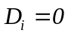for rural households and 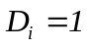for urban households

Two Alternatives: (1) Given X and D = 0, 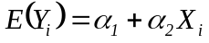; (2) Given X and D = 1,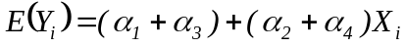
The PRFs will differ depending on statistical significance and sign of α₃ and α₄

Possibilities
- If both α₃ and α₄ are not significant, the two PRFs will coincide indicating not significant difference

- If α₃ is significant and α₄ is not, the two PRFs will be parallel (structural difference only in respect of intercept)
- If α₃ is positive, PRF for urban households will have higher intercept; (b) If α₃ is negative, PRF for urban households will have lower intercept

- If α₄ is significant and α₃ is not, the two PRFs will be concurrent (structural break - difference will be only in respect of slope)
- If α₄ is positive, PRF for urban households will be steeper; (b) If α₄ is negative, PRF for these households will be flatter

- If both α₃ and α₄ are significant, the two PRFs will be dissimilar
- If both α₃ and α₄ positive, PRF for urban households will be steeper with a higher intercept
- If both α₃ and α₄ negative, PRF for urban households will be flatter with a lower intercept
- If α₃ is positive but α₄ is negative, PRF for urban households will be flatter with a higher intercept
- If α₃ is negative but α₄ is positive, PRF for urban households will be steeper with a lower intercept

Multiple Regression Analysis: A Summary
Multiple Regression Model:
Other Models: (1); (2); (3); (4)
Aspect | Estimator
OLS estimator of 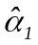 | 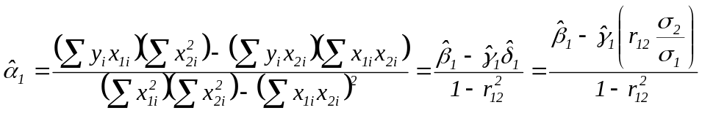
OLS estimator of 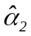 | 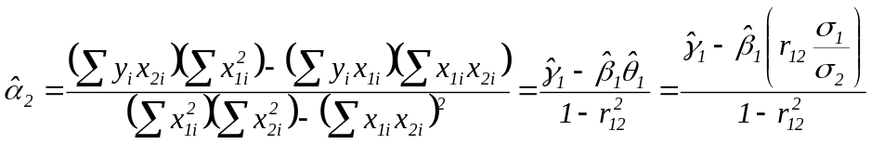
OLS estimator of 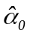
OLS estimator of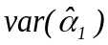and 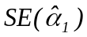 | and 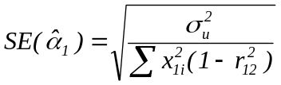
OLS estimator of 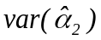and 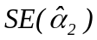 | and 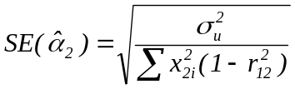
OLS estimator of 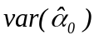 and 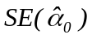 | 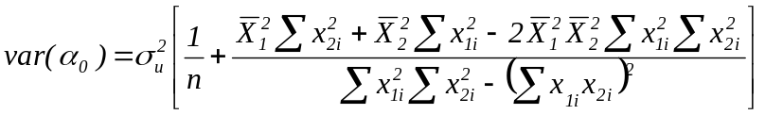; and  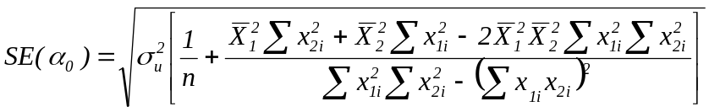
Explanatory Power of the Estimated Model | 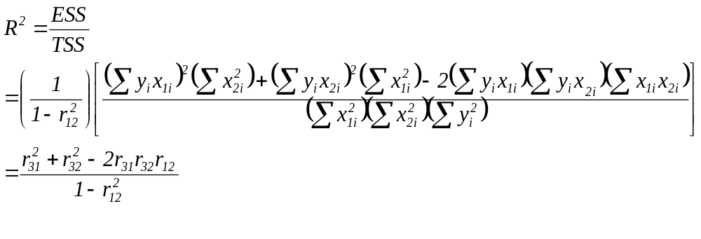
Adjusted R² | 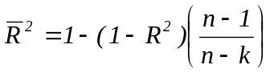
Covariance between and

Multicollinearity

Reasons of Multicollinearity Consequences Symptoms and Statistical Tests Remedies Possible Consequences
High R²; Few/No Significant Coefficient
Change in Significance of Other Variables

Symptoms
High Correlation Coefficients
Change in Sign of Other Variables

Sampling Problem
High Variance Inflation Factors
Dropping Variable(s)
Model Specification
Loss of Information on Variables

Severity of Multicollinearity
Combination of Variables
Derived Variables
Heteroscedasticity

Statistical Test
Farrar-Glaubar Test
Remedial Measures
Ratios of Variables
True Correlation
Non-linearity

Large Standard Errors of Coefficients
Change in Sign of Coefficients
Effect on Value of Coefficients
Model not Significant

Autocorrelation

First Difference of Variables
Model not Significant

Misleading Conclusions on Regression Results

